**ISE420 hw#4 Name: Bolun Xu**

9.10

2.

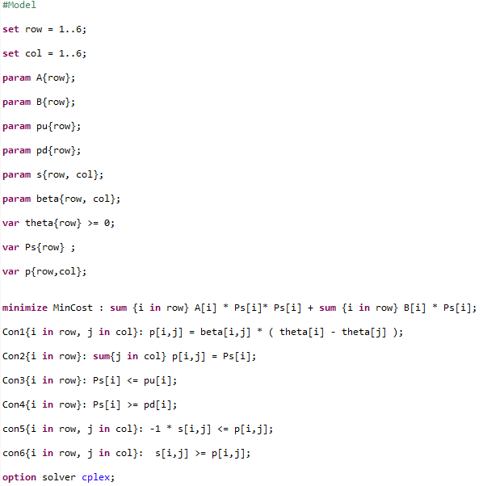

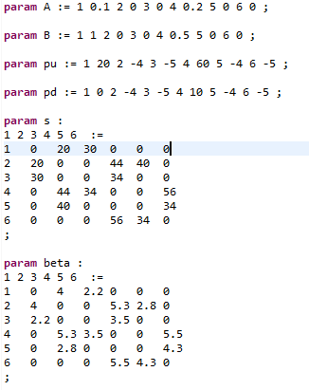

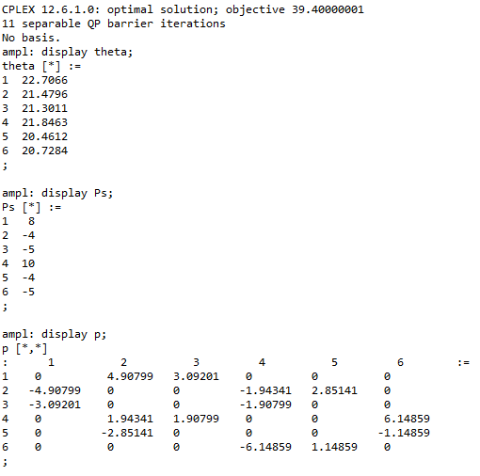

A: Optimal quantities of gens: P1=8;P4=10;

All load is satisfied:

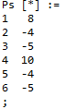

Total cost =39.4;

3.

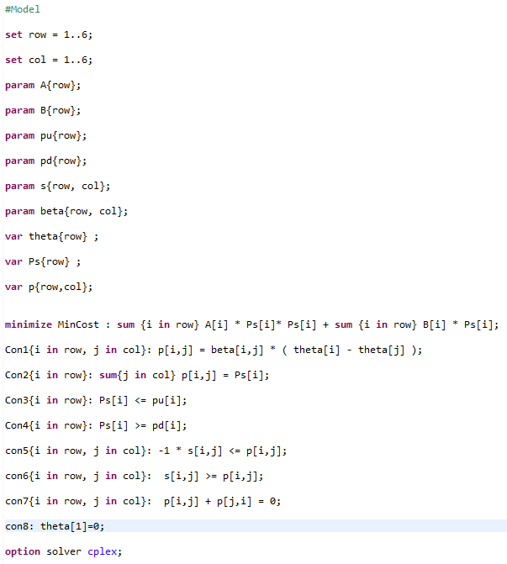

Put qij=0 means set θi=0;

Data does not change.

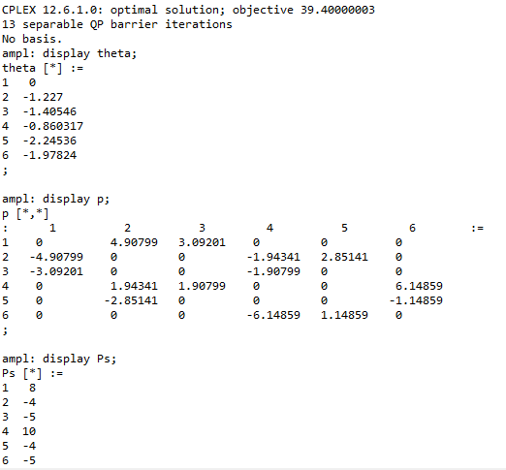

We only add contraints:

pij+pji=0; & qij == 0.

It does not change the optimal solution.

4.1 

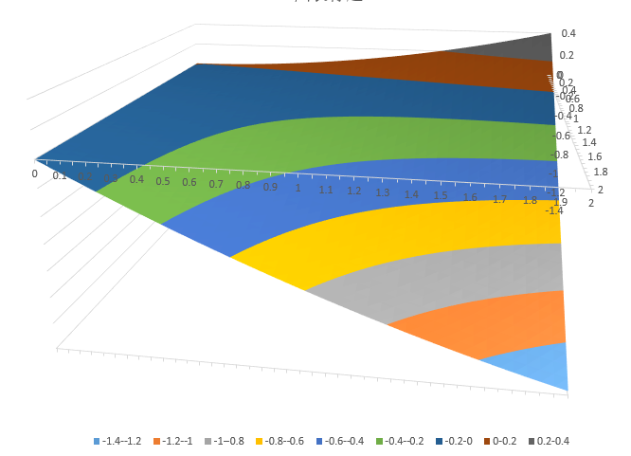

4.2 

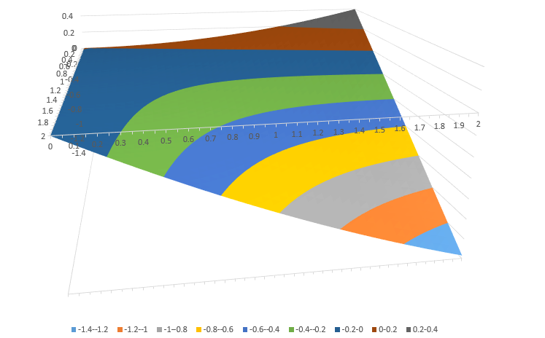

They are not convex functions of the voltage magnitudes.